Assignment 1 – Screen Time Habits
Survey Screen shots:
https://docs.google.com/forms/d/e/1FAIpQLScUmA4T5rHdgZWxeOpt60U8E1OzNCVmVHE3dXcDxgEj9eMmSw/viewform?pli=1&pli=1

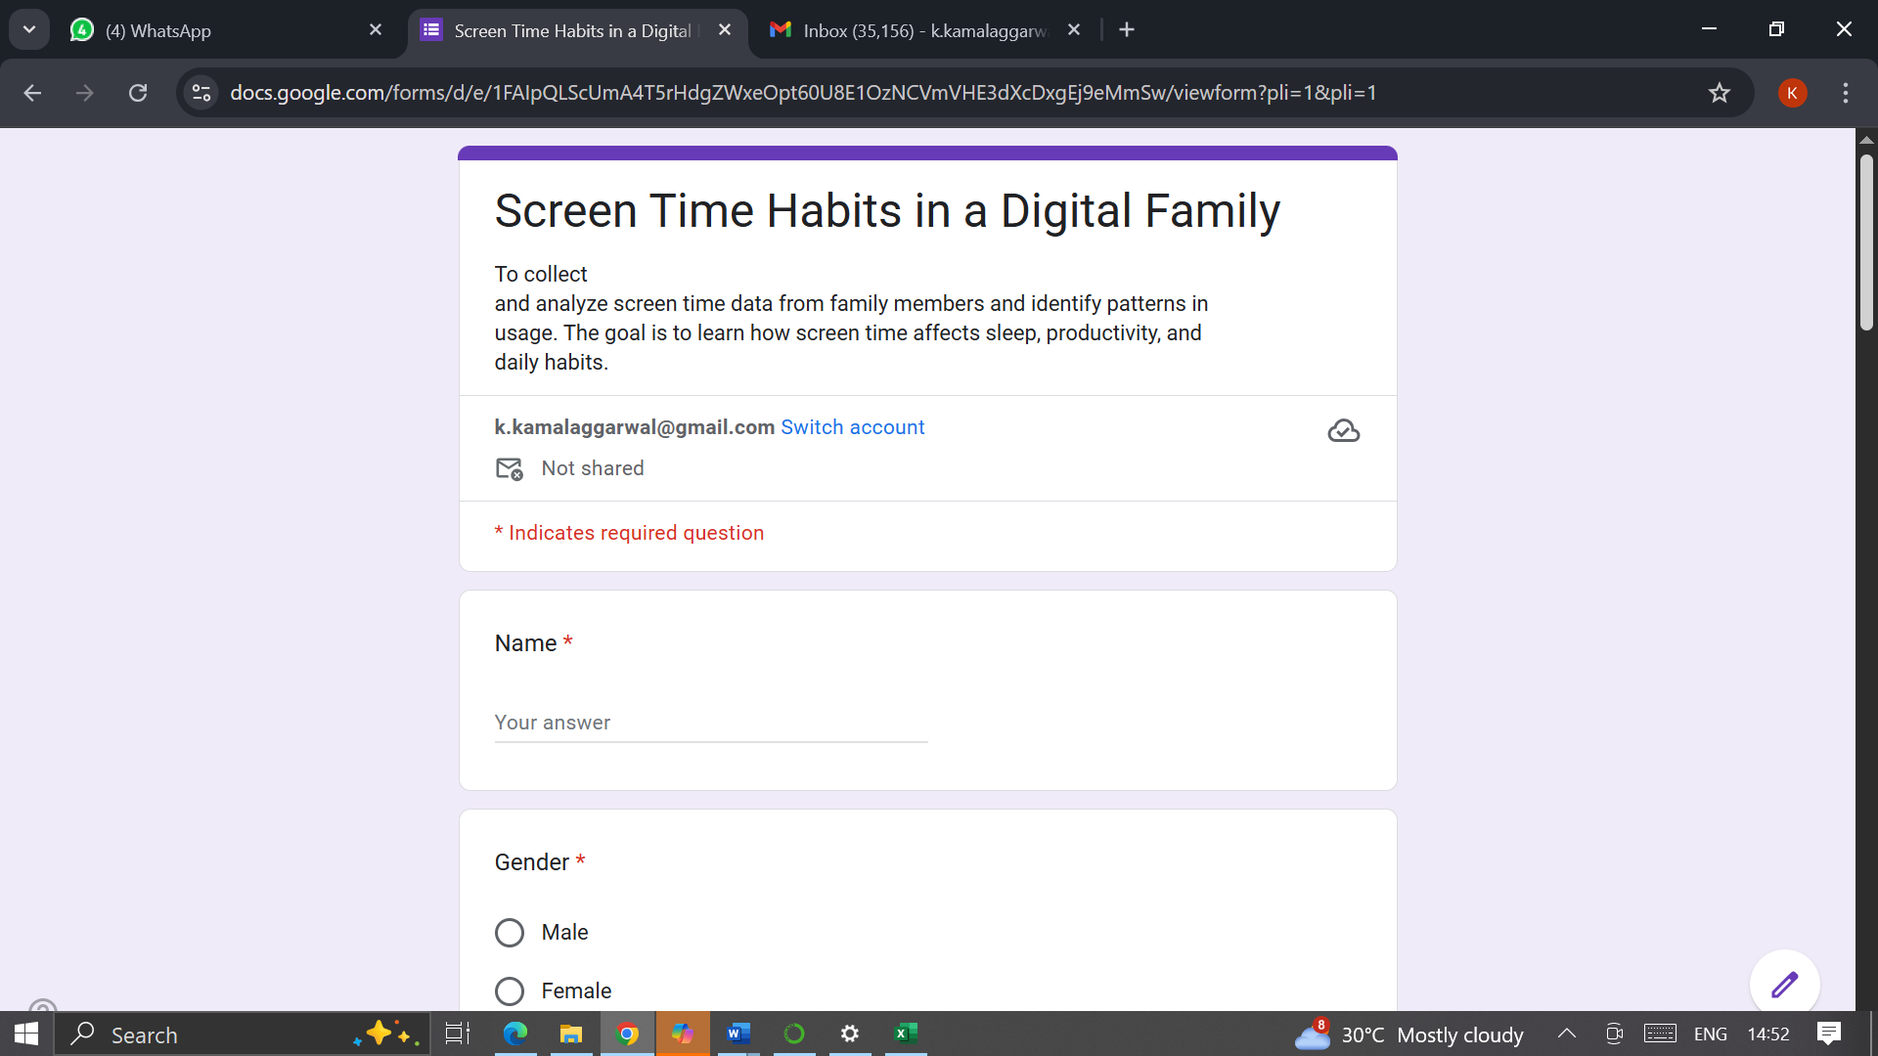
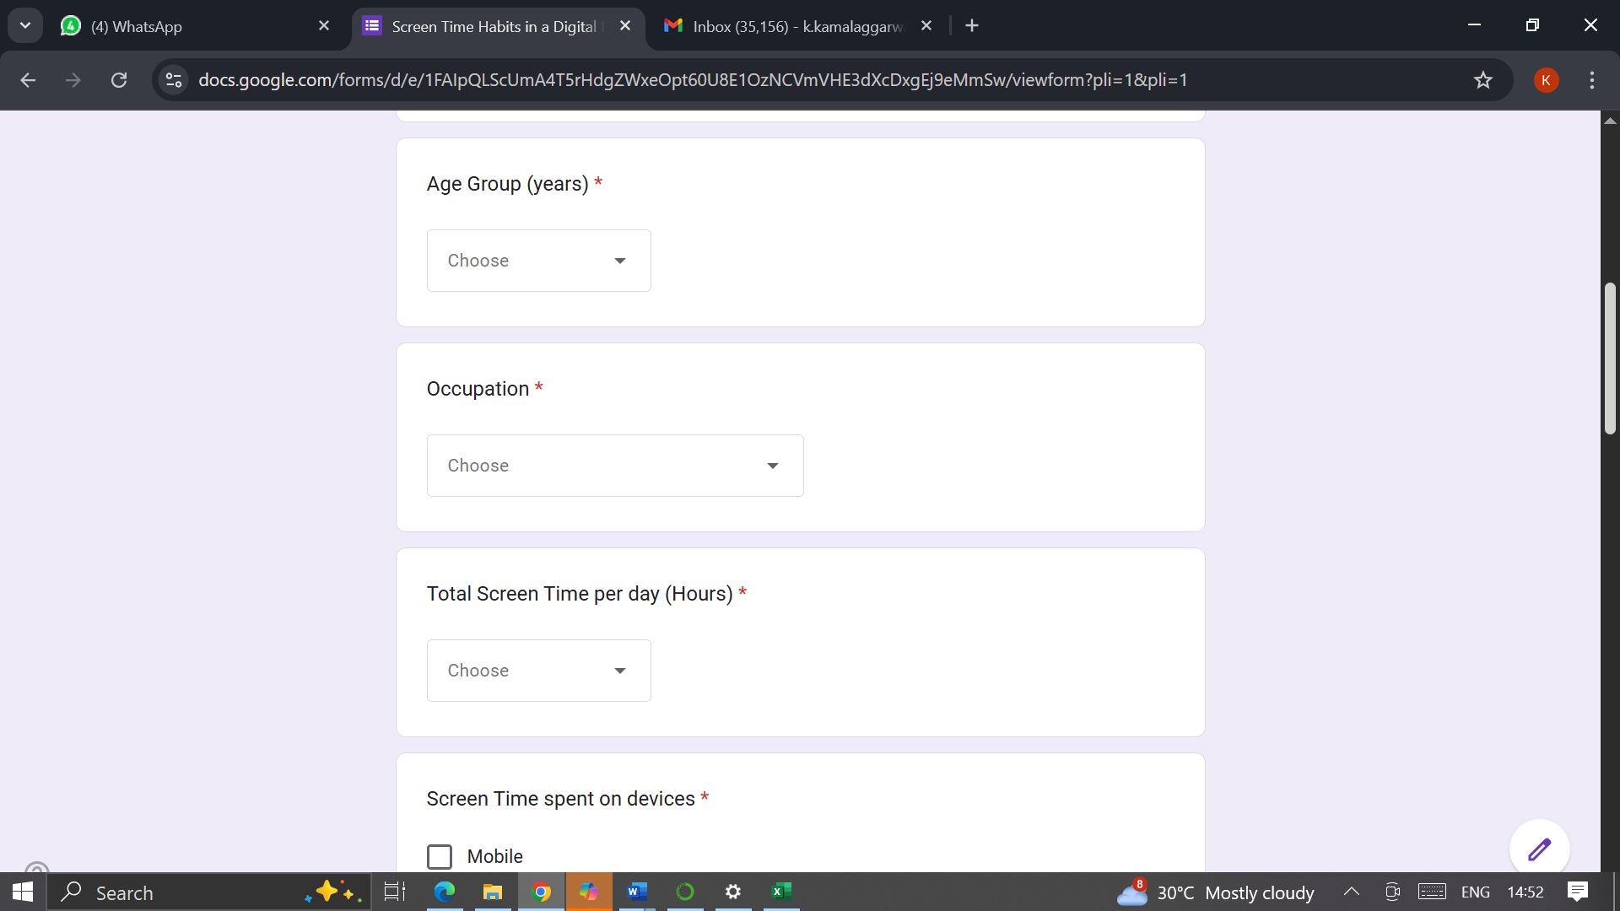

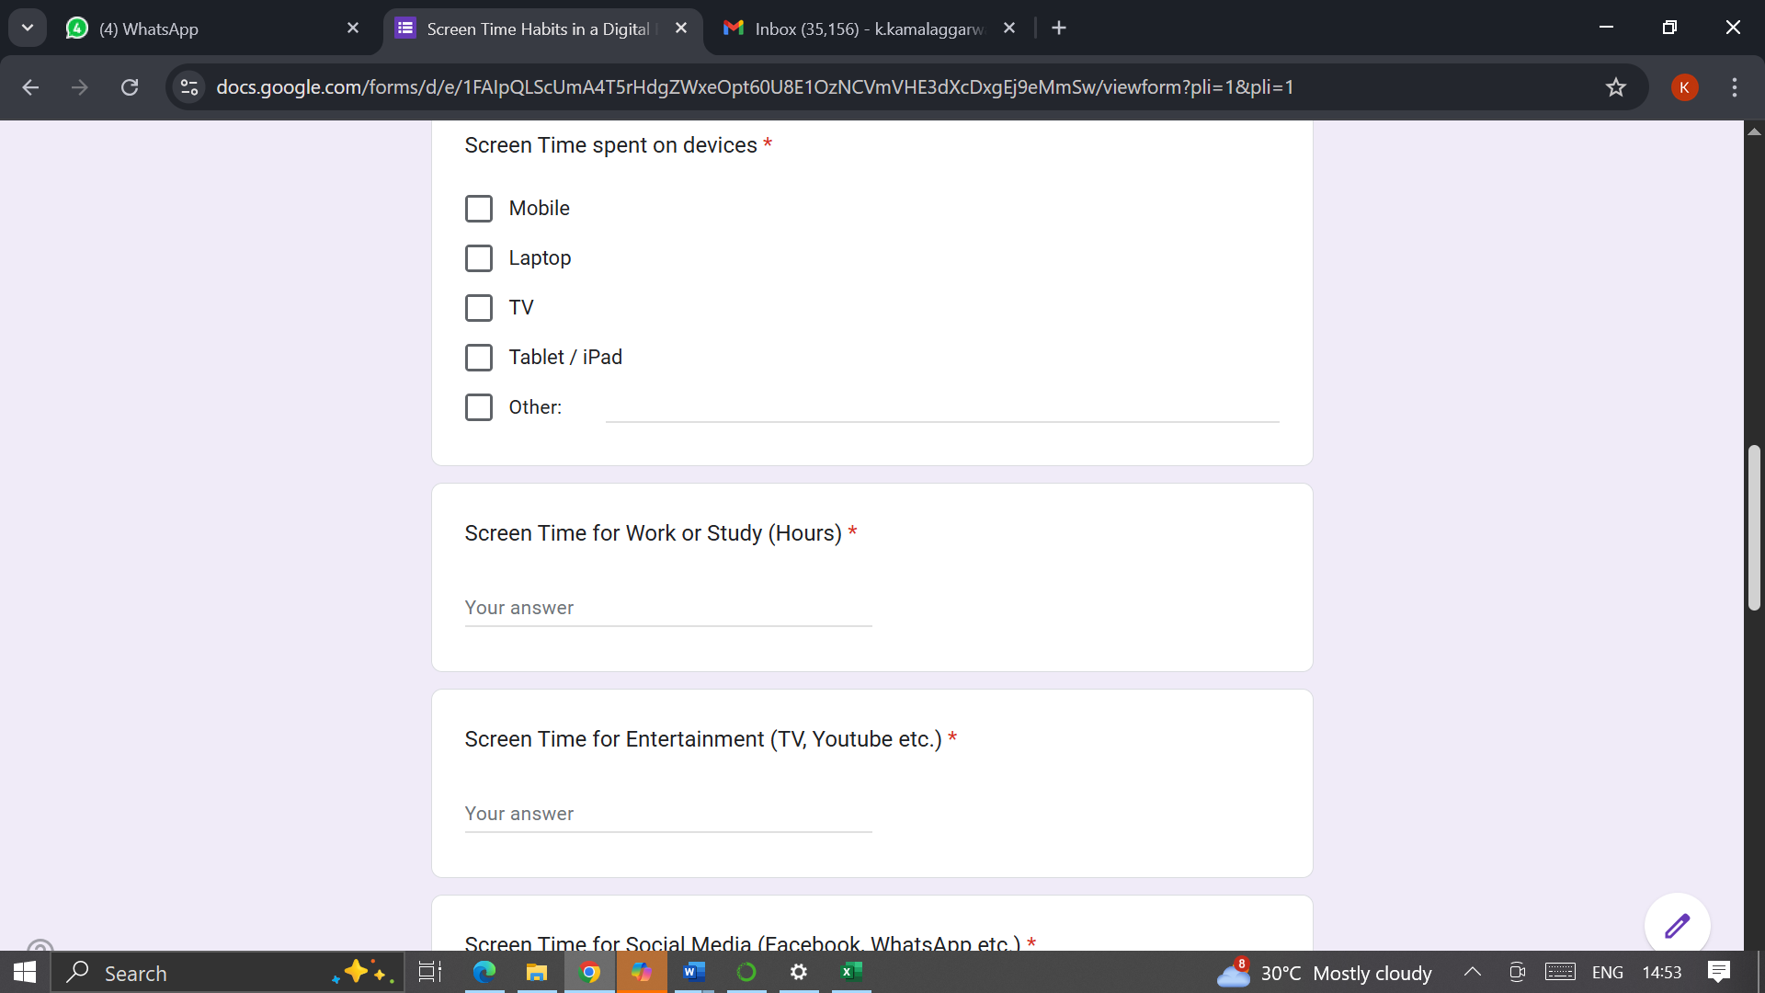

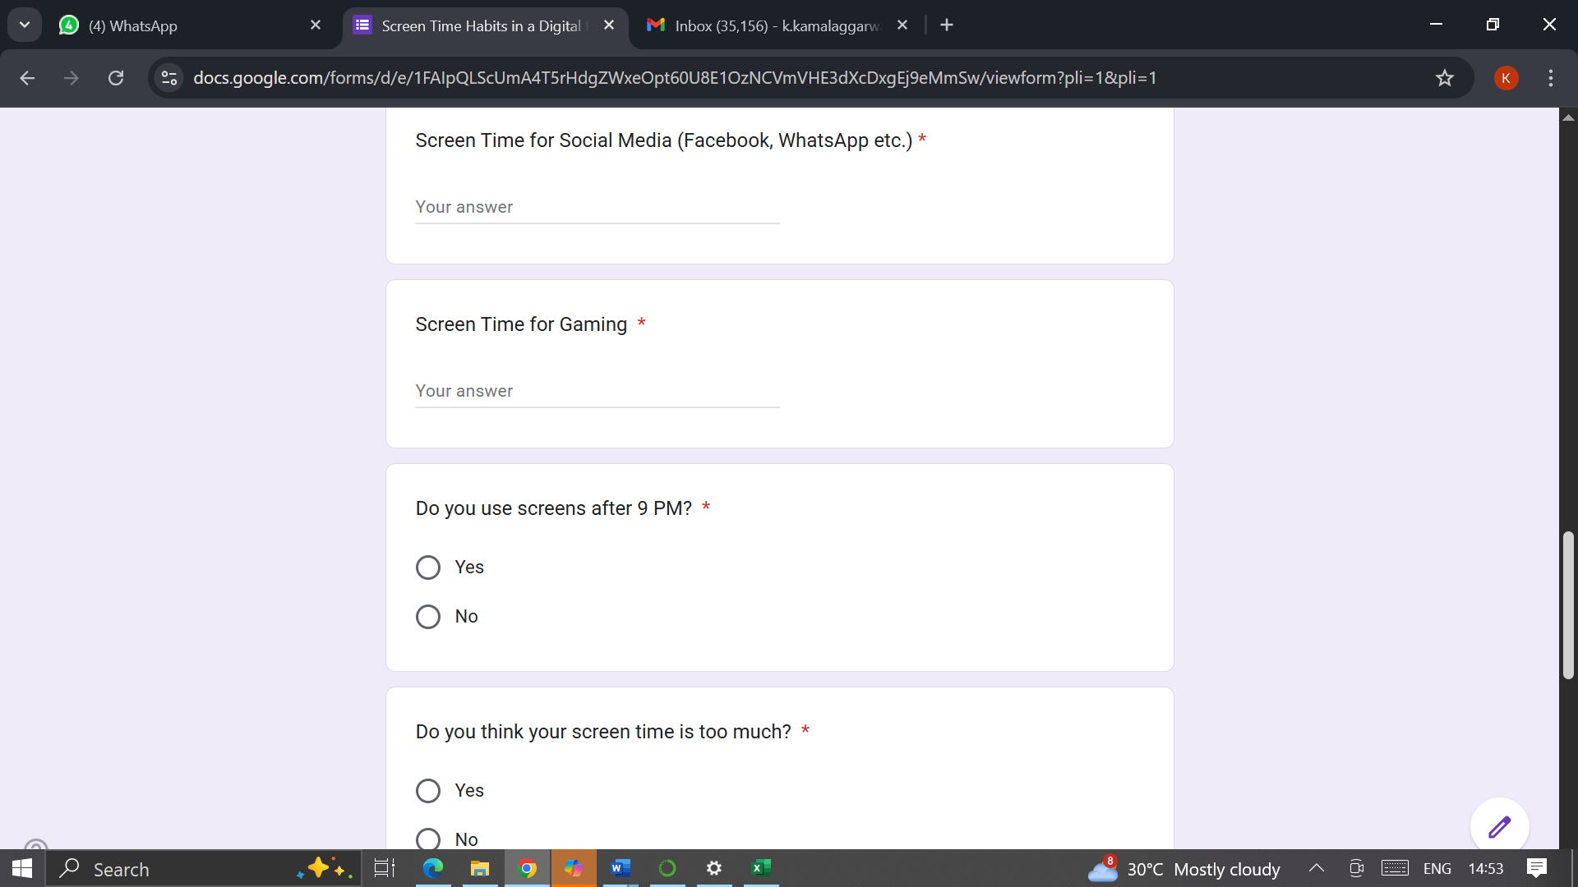

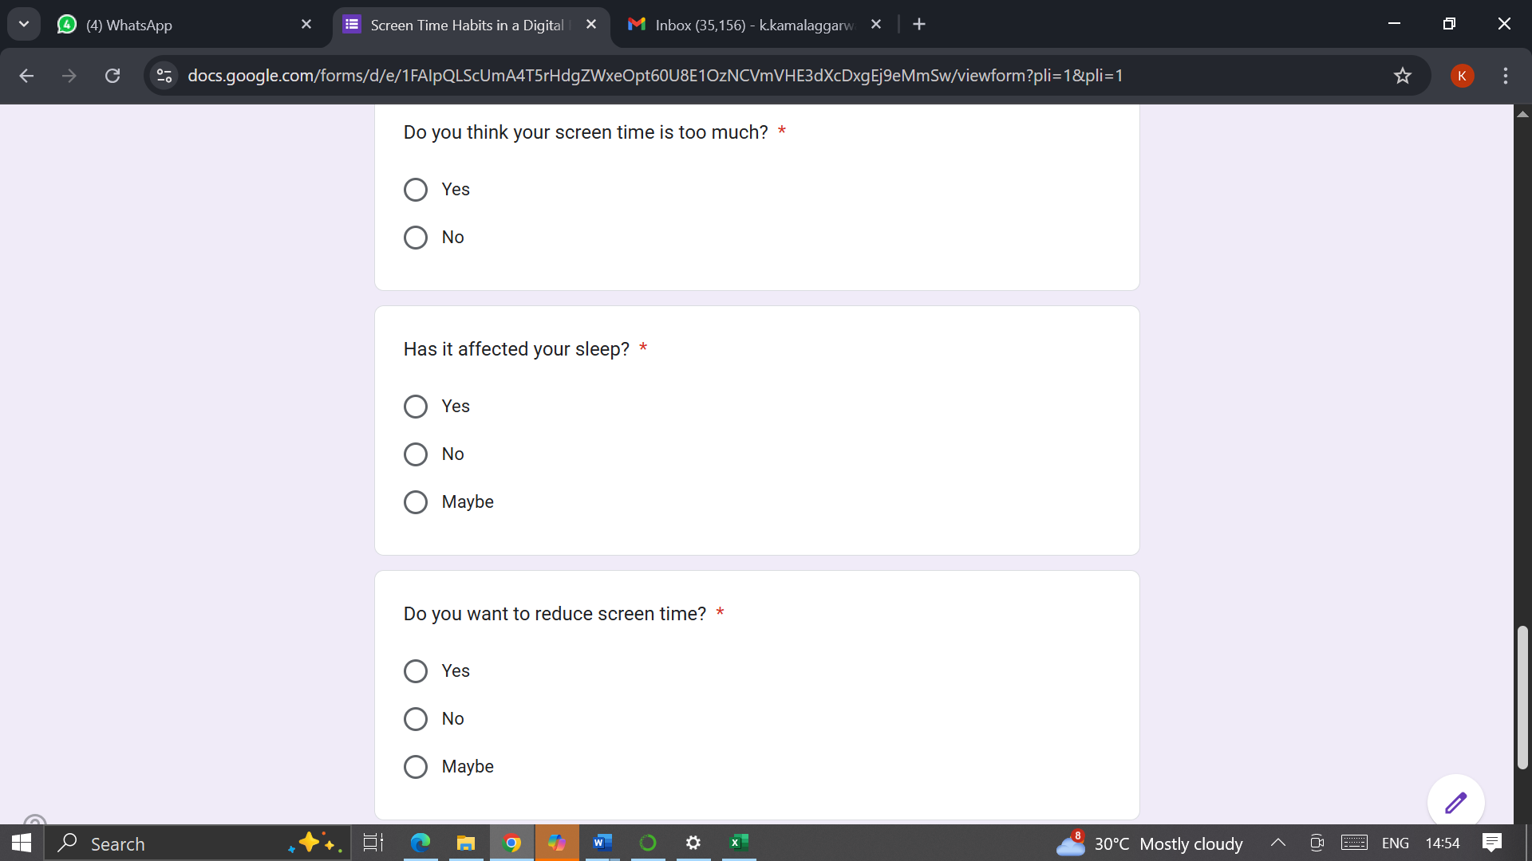

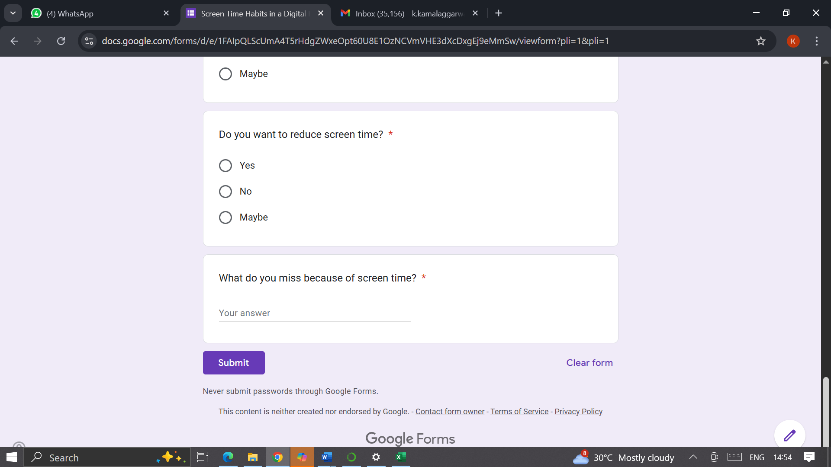

Key Findings:
- Sample data does not contain details for Age Group 19 – 30.
- Maximum respondents belonged to Age Group 31 – 50

Observations:
- People of Age Group 31 – 50 years having maximum screen time spent on Work or Study
- People from all the Age Groups are glued to Mobile for the screen time
- Mixed feedback in terms of Sleep impact because of screen time.
Suggestions to improve screen habits:
- Spend quality time with the family
- Engage in indoor / outdoor games
- Read books to gain knowledge

